User Guide
For BCD store system

2012.5.2
Zhengwei Pu
Long Ma
This project is implemented by using C# and Access.
When open the .exe file, the main menu will be displayed on the screen.
The main menu is displayed as below in figure1.
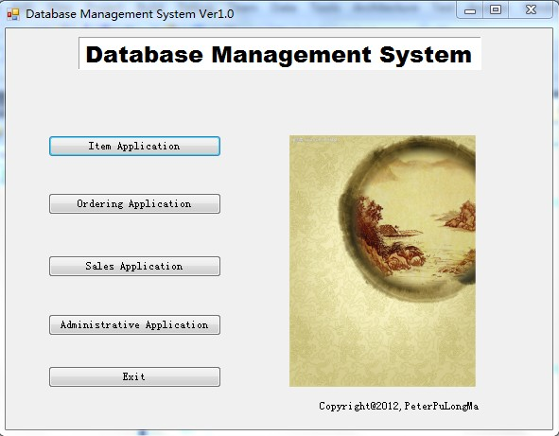
Figure 1
Those five buttons are used to access separated menu: Item menu, ordering menu, sales menu, administration menu and exit button used to exit this system.
When click the Item Application button, the menu is showed below as figure 2.
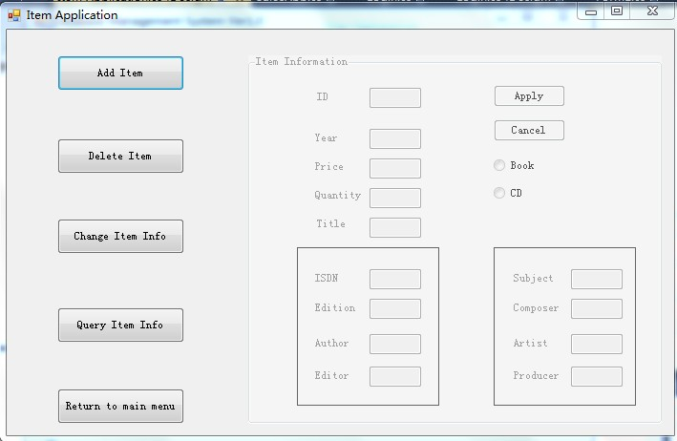
Figure 2
We can do some actions after clicking the buttons at left panel. Every different buttons lead to different operations.
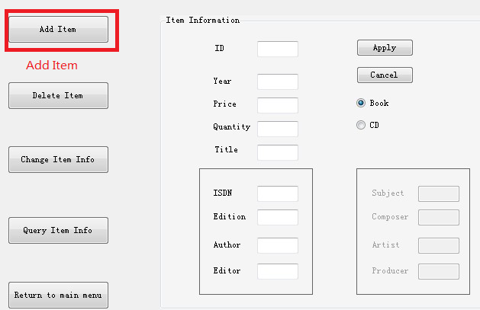
The radio button at right panel decides which subject this item is. We design two subjects for item as BOOK and CD. When finished typing the information of item, click the apply button to store this item into separate table or click the cancel button to cancel the editing this item’s information.
We just need an item ID to implement the deletion or query of item.
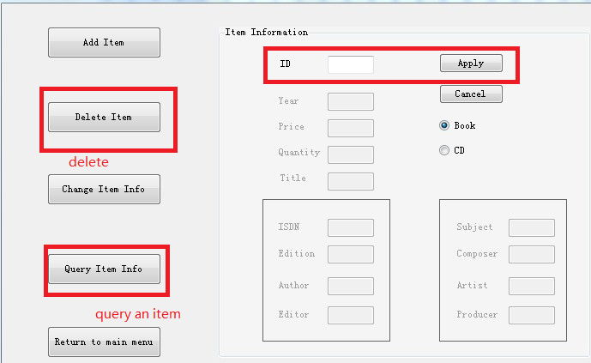
In the Ordering application menu, we also just need order ID to implement the deletion and query of order. It needs totally five different items in the text boxs to finish the “Place new order” or “Change Existing Order” operation. The system will pop up error tips if the input is not correct.
We need administration access permissions before entering the sales Application and Administrative Application.
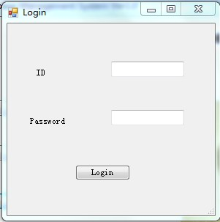
It needs saleID, itemID, employeeID, customerID, itemQuantity and vendorID to finish the sell operation. The system will check the correctness of these information.
When click the sale report button, it will pop up a new form to show the report.
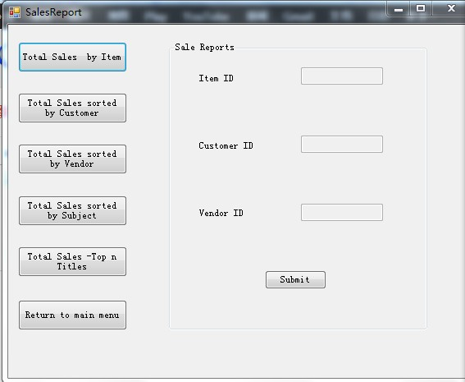
When those buttons are clicked, it will require different kinds of input then display the query result in a pop-up window.

